**620574-EPP-1-2020-1-NO-EPPKA3-VET-COVE Erasmus+ Center of Vocational Excellence** **bridges.eu**

**Deliverable: D10.3**

**Swedish industry in education partnership**

**________________________________________**

**WP 10: VET responsiveness towards industry needs**

**WP Leader: BCC**

**Contributor: GG**

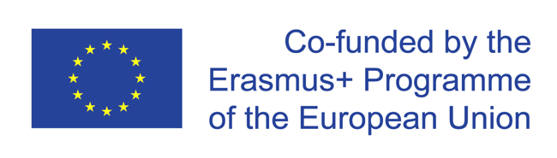

The European Commission support for the production of this publication does not constitute endorsement of the contents which reflects the views only of the authors, and the Commission cannot be held responsible for any use which may be made of the information contained therein.

**Background:**

In meetings in our ASFF-group (SFÅ-ASFF) both industry and educators have expressed the wish for more cooperation in the actual learning situation. The benefits of this are, that the educator teaches exactly what the industry requires and that the students get a deeper understanding of the aquaculture profession.

Therefore, an aquaculture worker from Nordic Trout (Marcus) came to Gullmarsgymnasiet on the 1st of March to talk about his work. He addressed skills required, competences needed and how a normal day of work is.

There was time for the students to ask questions and discuss with Marcus.

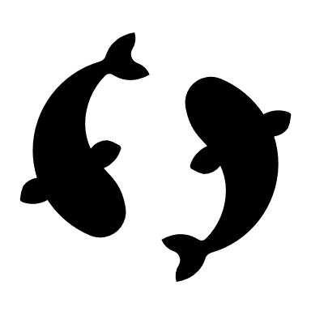

Outcomes:

The outcomes of this trial were liked by students and industry.

The students were very curious and asked a lot of questions. The students expressed a feel for what a Swedish aquaculture worker does during a days work. More students stated a will to work in aquaculture than before the visit.

Because of the student’s reaction and the feedback from the worker and Nordic Trout – we aim to continue this type of learning in the future. We believe that the industry and the educators have to a bigger responsibility for the student’s education. Some of this work will be done through SFÅ-ASFF. We have also discussed the possibility to equipe a worker with a GoPro camera and teach while working.

**COPYRIGHT**

©Copyright 2020-2024 the Bridges Consortium, consisting of:

* Trøndelag County Authority (TC), Norway
* Gullmarsgymnasiet/Lysekils Vuxenutbildning (GG), Sweden
* Peimari Group for Further Education and Training (Livia), Finland
* Icelandic College of Fisheries (ICF), Iceland
* Holar University (Holar), Iceland
* University of Akureyri (Akureyri), Iceland
* SalMar Farming (Salmar), Norway
* Arnarlax (Arnarlax), Iceland
* Nordic Trout (NT), Finland
* Nordic Trout Sweden (NTS), Sweden
* Blue Competence Centre (BCC), Norway
* Easy Learning Solutions (ELS), Norway

This document may not be copied, reproduced or modified in whole or in part for any purpose without written permission from the Bridges Consortium. In addition to such written permission to copy, reproduce or modify this document in whole or part, an acknowledgement from the authors of the document and all applicable portions of the copyright notice must be clearly referenced.

All rights reserved.

This document may be updated if needed and changed without notice.



The European Commission support for the production of this publication does not constitute endorsement of the contents which reflects the views only of the authors, and the Commission cannot be held responsible for any use which may be made of the information contained therein.