**620574-EPP-1-2020-1-NO-EPPKA3-VET-COVE Erasmus+ Center of Vocational Excellence** **bridges.eu**

**Deliverable: D10.4**

**Vocational and education exhibition trade fair**

**________________________________________**

**WP 10: Implementation VET responsiveness towards industry needs**

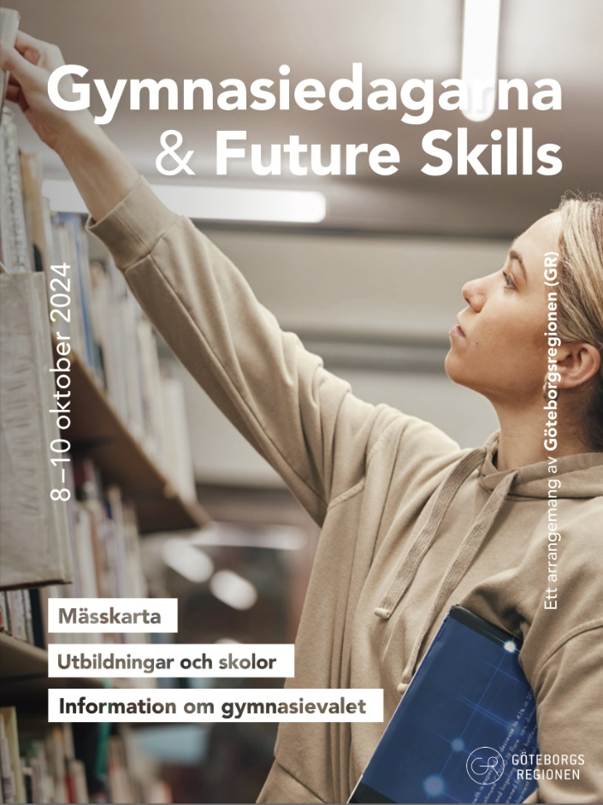

**WP Leader: BCC**

**Contributor: GG**

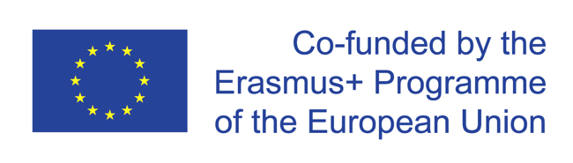

The European Commission support for the production of this publication does not constitute endorsement of the contents which reflects the views only of the authors, and the Commission cannot be held responsible for any use which may be made of the information contained therein.

**Representation at trade fair: Gymnasiedagarna and future Skills Gothenburg 8-10 October 2024**

Gullmarsgymnasiet had four students and one teacher representing our marine educations at the high school fair in Gothenburg 8-10 October 2024. On this trade fair we presented our vocational aquaculture education and our marine biology education. The potential students were interested in the diversity of work opportunities and the industry contacts we have gained through the Bridges project.

In total there were 16 000 students on the fair these three days, mostly 9th graders who will make their high school choice in December.

Outcomes:

Our goal for participating in these trade fairs was to get 9th graders to apply to Gullmarsgymnasiets upper secondary vocational blue programs.

The outcomes of these trade fairs were successful. After talking to a lot of students, parents, teachers and other interested we had many potential applicants to our upper secondary vocational blue programs.

The presentation of Bridges and its outcomes helped us in this due to our connections with the industry and our contacts within the Bridges program which might give the students a possibility to do their internship abroad.

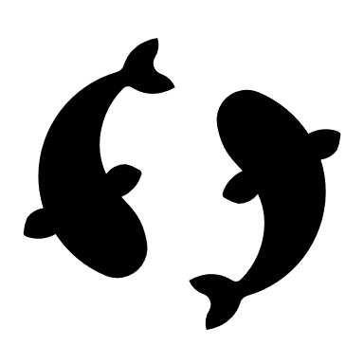

**COPYRIGHT**

©Copyright 2020-2024 the Bridges Consortium, consisting of:

* Trøndelag County Authority (TC), Norway
* Gullmarsgymnasiet/Lysekils Vuxenutbildning (GG), Sweden
* Peimari Group for Further Education and Training (Livia), Finland
* Icelandic College of Fisheries (ICF), Iceland
* Holar University (Holar), Iceland
* University of Akureyri (Akureyri), Iceland
* SalMar Farming (Salmar), Norway
* Arnarlax (Arnarlax), Iceland
* Nordic Trout (NT), Finland
* Nordic Trout Sweden (NTS), Sweden
* Blue Competence Centre (BCC), Norway
* Easy Learning Solutions (ELS), Norway

This document may not be copied, reproduced or modified in whole or in part for any purpose without written permission from the Bridges Consortium. In addition to such written permission to copy, reproduce or modify this document in whole or part, an acknowledgement from the authors of the document and all applicable portions of the copyright notice must be clearly referenced.

All rights reserved.

This document may be updated if needed and changed without notice.



The European Commission support for the production of this publication does not constitute endorsement of the contents which reflects the views only of the authors, and the Commission cannot be held responsible for any use which may be made of the information contained therein.